**Message REST**

3 entities: Dialog, Users and Message

**Relationships**

Dialog *-* Users /Dialog 1-* Message/Users *-* Dialog/Users 1-* Message

**Description:**

This REST Webservice and client allow you to send messages between users in dialogs.

------------------------------------------------------------------------------------------------------------------------------------------

Create new user using POST <http://localhost:8080/Message/rest/users>

{“firstName”:”…”,”lastName”:”…”,”age”:”…”}

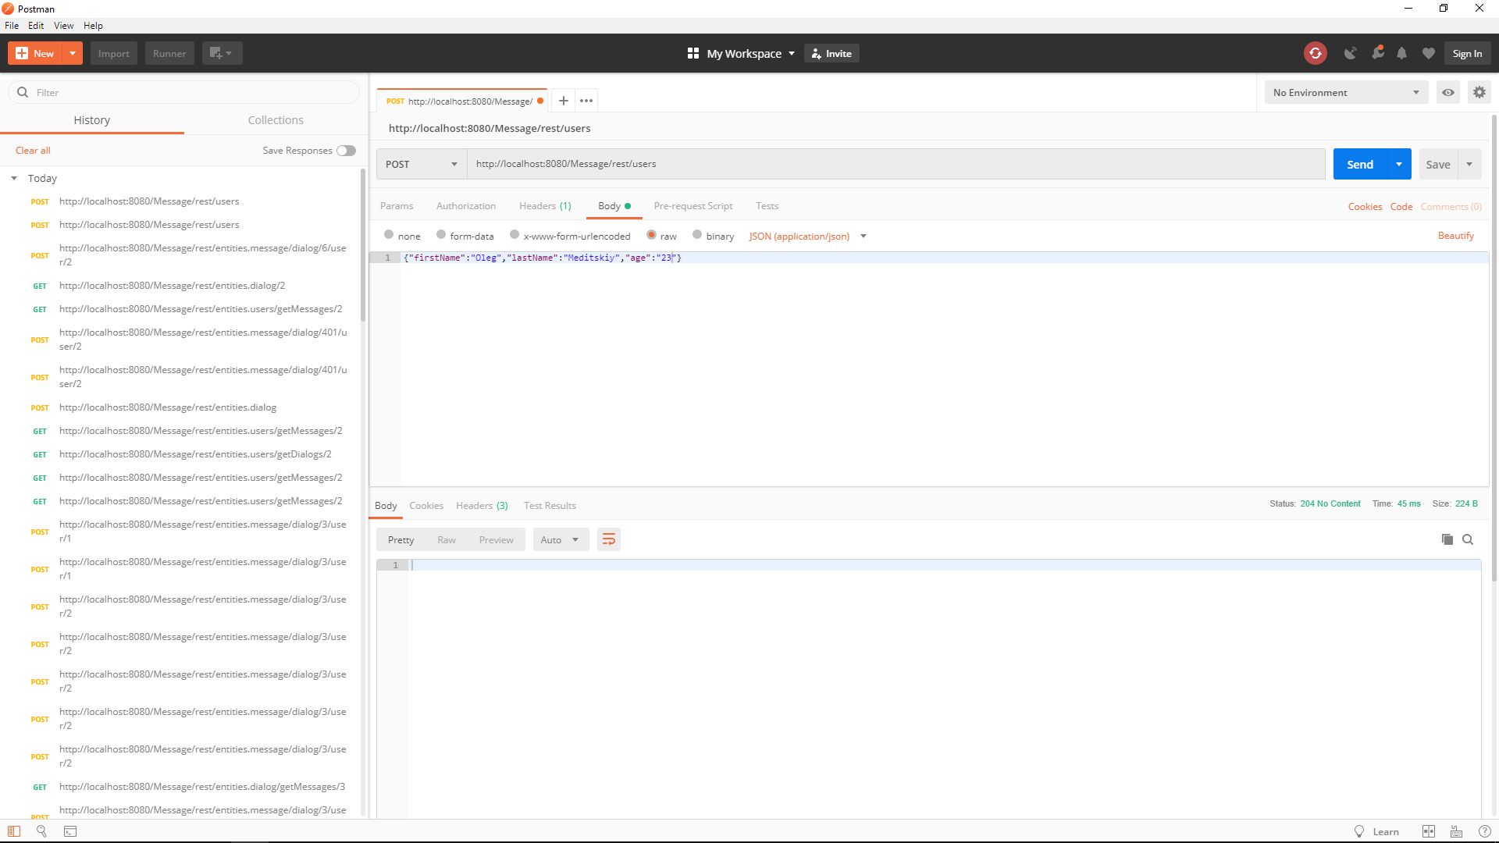

Get user list using GET <http://localhost:8080/Message/rest/users>

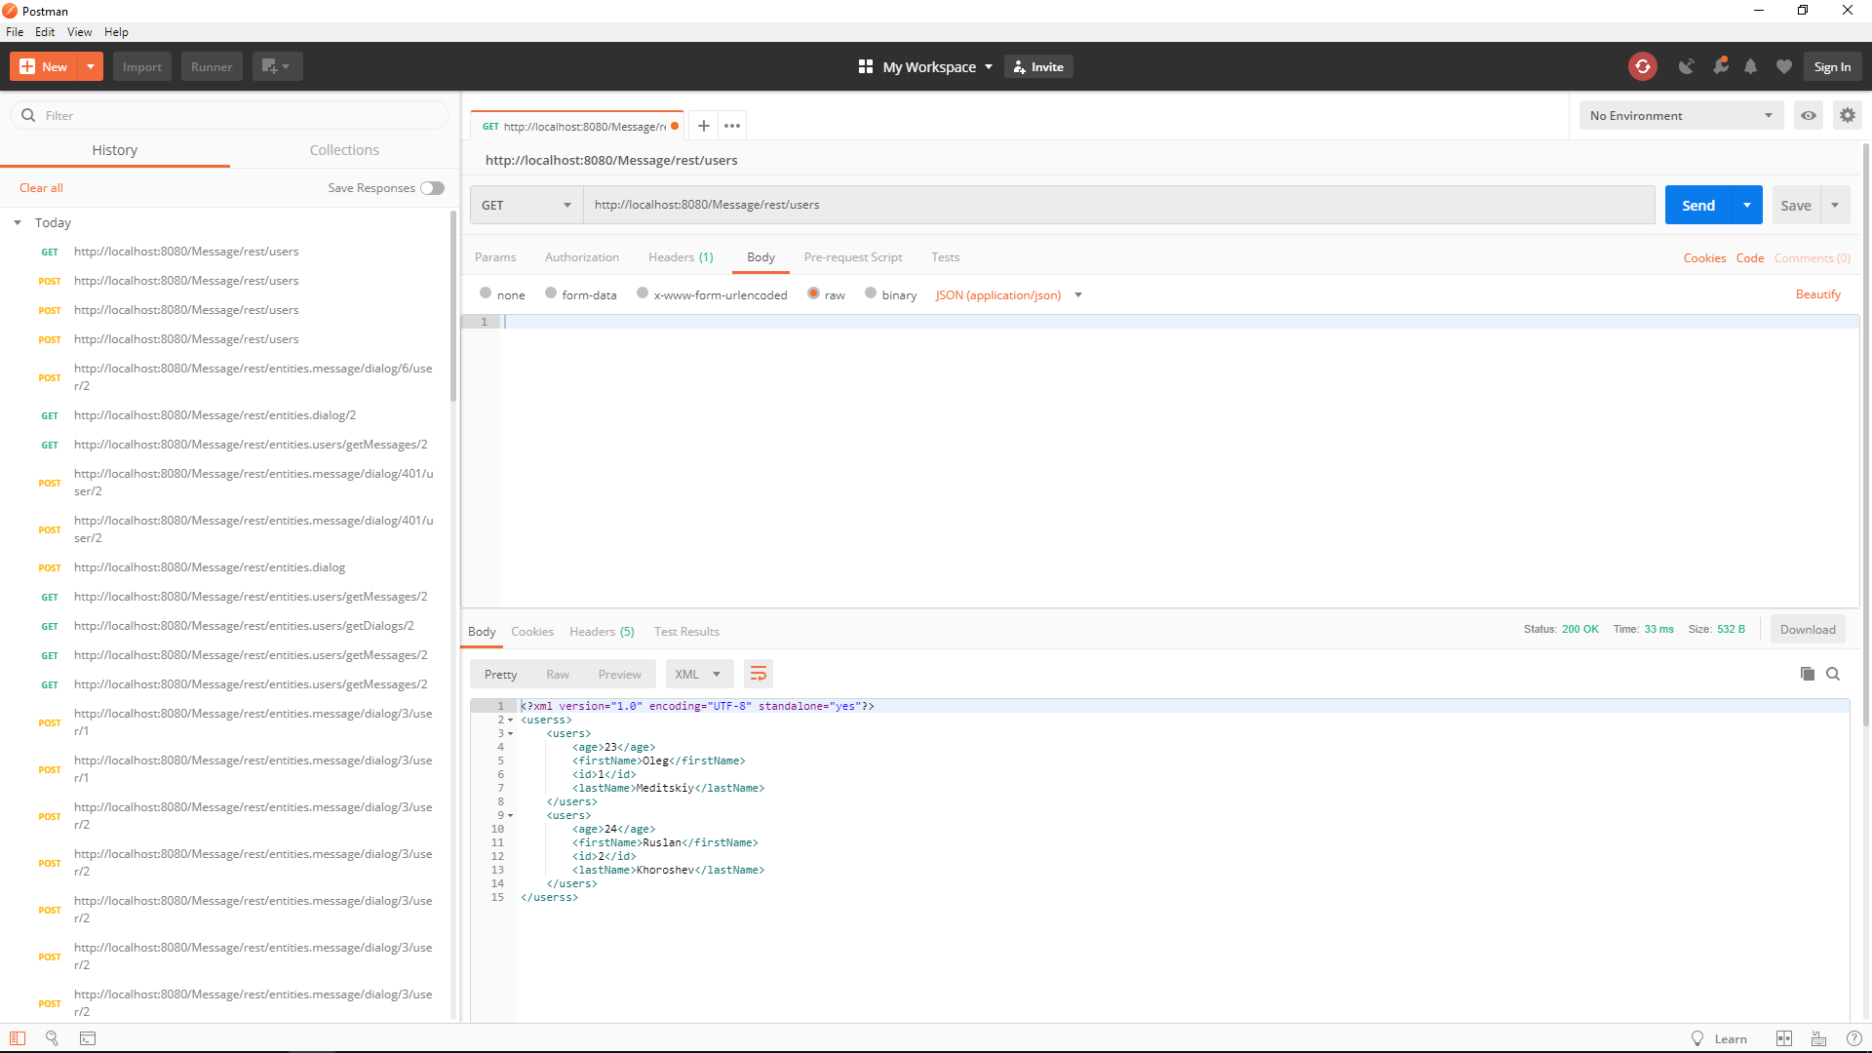

Create new dialog using POST <http://localhost:8080/Message/rest/dialog>

{"name":"Oleg-Ruslan-Dialog"}

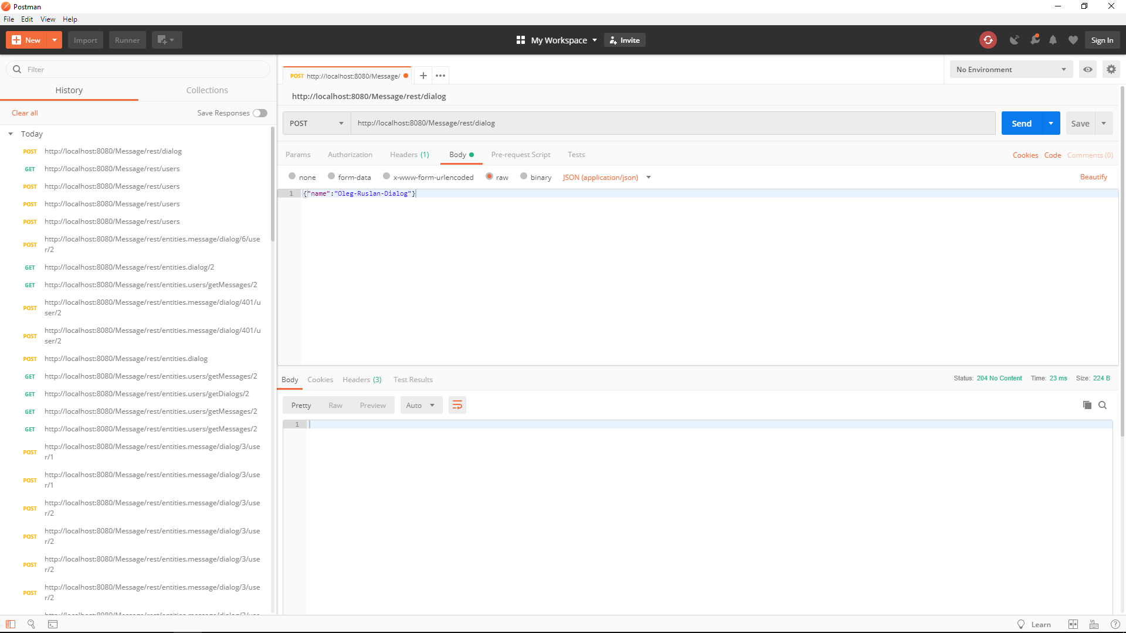

Get dialog list using GET <http://localhost:8080/Message/rest/dialog>

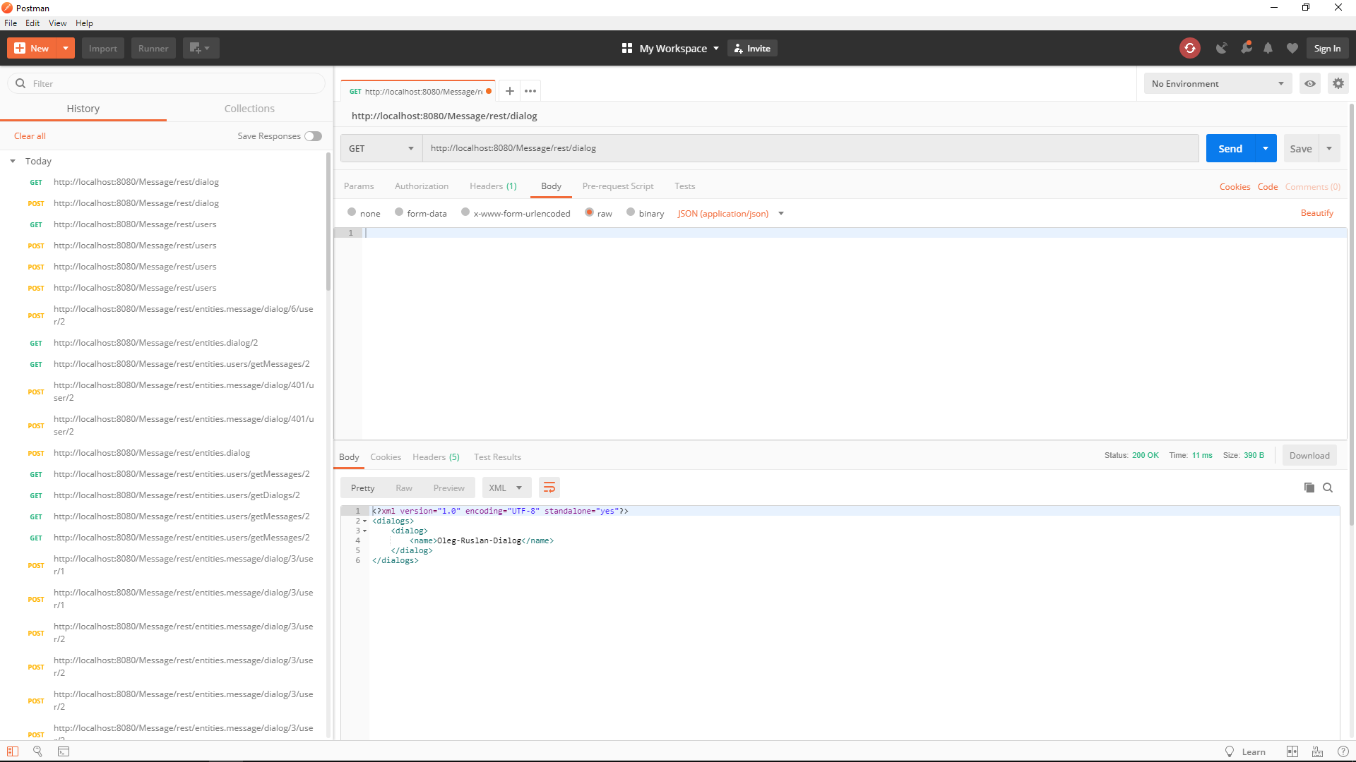

Create message using POST <http://localhost:8080/Message/rest/message/dialog/3/user/1>

Write dialog id first then user id and message in body

{"message":"Hi Ruslan, i want to meet you today."}

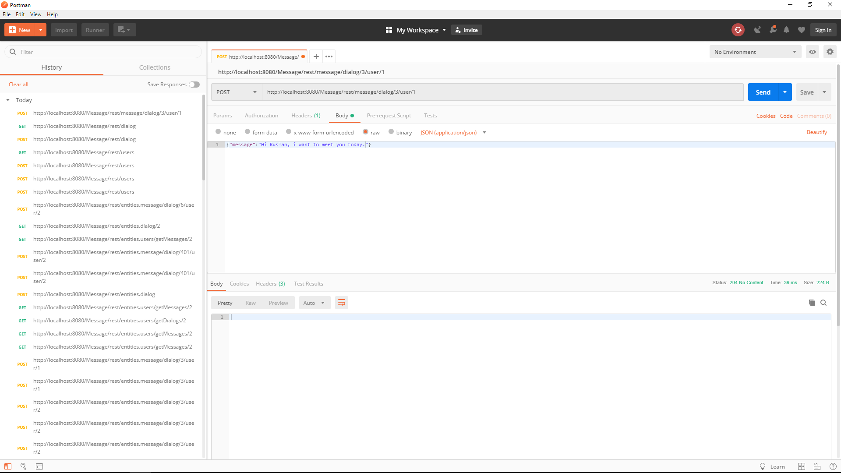

Get all messages from Dialog using GET <http://localhost:8080/Message/rest/dialog/getMessages/3>

Write dialog id after getMessages

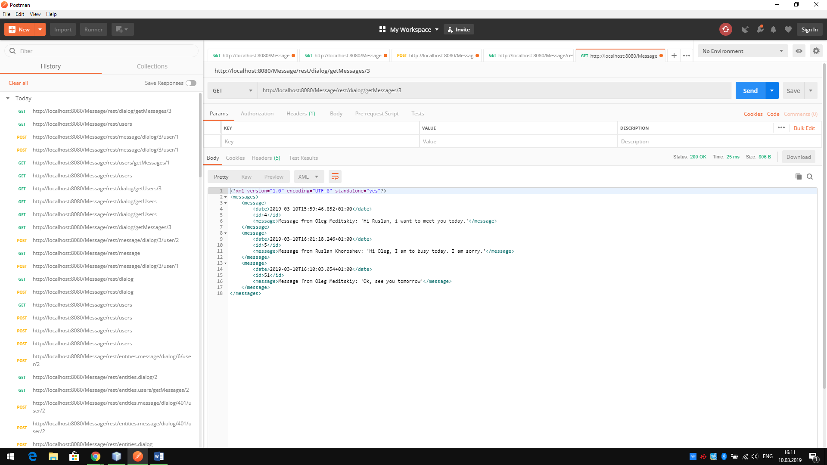

You can also:

* get dialog’s users using GET <http://localhost:8080/Message/rest/dialog/getUsers>
* get user’s messages using GET <http://localhost:8080/Message/rest/users/getMessages/1> Write user id after getMessages
* get user’s dialogs using GET <http://localhost:8080/Message/rest/users/getDialogs/1> Write user id after getDialogs